**WEEK 3 ASSESMENT**

Using ALV, display Header details.  
•    When double clicked on document-number display item data corresponding to document number.  
•    Double clicked on payer number in header table. Go to transaction ‘xd03’and skip the first screen and display payer details.  
•    Double clicked on material number in item table. Go to transaction ‘mm03’and display material details.

PACKAGE: ZUST_GLOBAL

PROGRAM NAME: ZPS_ASSESMENT_ALV.

DATA: IT_VBRK TYPE STANDARD TABLE OF ZVBRK_PS.  
DATA: IT_VBRP TYPE STANDARD TABLE OF ZVBRP_PS.  
  
DATA : lt_fcat TYPE SLIS_T_FIELDCAT_ALV,  
 lw_fcat LIKE LINE OF lt_fcat.  
DATA : V_VBELN TYPE ZVBRK_PS-VBELN.  
SELECT-OPTIONS S_VBELN FOR V_VBELN.  
  
START-OF-SELECTION.  
 PERFORM get_data.  
  
END-OF-SELECTION.  
 PERFORM display.  
  
*\*&---------------------------------------------------------------------\**  
*\*& Form get_data*  
*\*&---------------------------------------------------------------------\**  
*\*& text*  
*\*&---------------------------------------------------------------------\**  
*\*& --> p1 text*  
*\*& <-- p2 text*  
*\*&---------------------------------------------------------------------\**  
FORM get_data .  
SELECT * FROM ZVBRK_PS INTO TABLE it_VBRK WHERE VBELN IN s_VBELN.  
SORT IT_VBRK BY VBELN.  
ENDFORM.  
*\*&---------------------------------------------------------------------\**  
*\*& Form display*  
*\*&---------------------------------------------------------------------\**  
*\*& text*  
*\*&---------------------------------------------------------------------\**  
*\*& --> p1 text*  
*\*& <-- p2 text*  
*\*&---------------------------------------------------------------------\**  
FORM display .  
  
 lw_fcat-col_pos = 1.  
 lw_fcat-fieldname = 'VBELN'.  
 lw_fcat-tabname = 'IT_VBRK'.  
 lw_fcat-seltext_m = 'DOCUMENT NO'.  
 lw_fcat-outputlen = 20.  
 lw_fcat-hotspot = 'X'.  
 APPEND lw_fcat TO lt_fcat.  
 CLEAR LW_FCAT.  
  
  
  
 lw_fcat-col_pos = 2.  
 lw_fcat-fieldname = 'FKDAT'.  
 lw_fcat-tabname = 'IT_VBRK'.  
 lw_fcat-seltext_m = 'DOCUMENT DATE'.  
 lw_fcat-outputlen = 15.  
 APPEND lw_fcat TO lt_fcat.  
  
 lw_fcat-col_pos = 3.  
 lw_fcat-fieldname = 'KUNRG'.  
 lw_fcat-tabname = 'IT_VBRK'.  
 lw_fcat-seltext_m = 'PAYER'.  
 lw_fcat-outputlen = 15.  
 lw_fcat-hotspot = 'X'.  
 APPEND lw_fcat TO lt_fcat.  
 CLEAR LW_FCAT.  
  
 lw_fcat-col_pos = 4.  
 lw_fcat-fieldname = 'NETWR'.  
 lw_fcat-tabname = 'IT_VBRK'.  
 lw_fcat-seltext_m = 'NETVALUE'.  
 lw_fcat-outputlen = 15.  
 APPEND lw_fcat TO lt_fcat.  
  
 CALL FUNCTION 'REUSE_ALV_GRID_DISPLAY'  
 EXPORTING  
*\* I_INTERFACE_CHECK = ' '*  
*\* I_BYPASSING_BUFFER = ' '*  
*\* I_BUFFER_ACTIVE = ' '*  
 I_CALLBACK_PROGRAM = 'ZPS_ASSESMENT_ALV'  
*\* I_CALLBACK_PF_STATUS_SET = ' '*  
 I_CALLBACK_USER_COMMAND = 'USER_COMMAND'  
*\* I_CALLBACK_TOP_OF_PAGE = ' '*  
*\* I_CALLBACK_HTML_TOP_OF_PAGE = ' '*  
*\* I_CALLBACK_HTML_END_OF_LIST = ' '*  
*\* I_STRUCTURE_NAME =*  
*\* I_BACKGROUND_ID = ' '*  
*\* I_GRID_TITLE =*  
*\* I_GRID_SETTINGS =*  
*\* IS_LAYOUT =*  
 IT_FIELDCAT = LT_FCAT  
*\* IT_EXCLUDING =*  
*\* IT_SPECIAL_GROUPS =*  
*\* IT_SORT =*  
*\* IT_FILTER =*  
*\* IS_SEL_HIDE =*  
*\* I_DEFAULT = 'X'*  
*\* I_SAVE = ' '*  
*\* IS_VARIANT =*  
*\* IT_EVENTS =*  
*\* IT_EVENT_EXIT =*  
*\* IS_PRINT =*  
*\* IS_REPREP_ID =*  
*\* I_SCREEN_START_COLUMN = 0*  
*\* I_SCREEN_START_LINE = 0*  
*\* I_SCREEN_END_COLUMN = 0*  
*\* I_SCREEN_END_LINE = 0*  
*\* I_HTML_HEIGHT_TOP = 0*  
*\* I_HTML_HEIGHT_END = 0*  
*\* IT_ALV_GRAPHICS =*  
*\* IT_HYPERLINK =*  
*\* IT_ADD_FIELDCAT =*  
*\* IT_EXCEPT_QINFO =*  
*\* IR_SALV_FULLSCREEN_ADAPTER =*  
*\* O_PREVIOUS_SRAL_HANDLER =*  
*\* IMPORTING*  
*\* E_EXIT_CAUSED_BY_CALLER =*  
*\* ES_EXIT_CAUSED_BY_USER =*  
 TABLES  
 t_outtab = IT_VBRK  
 EXCEPTIONS  
 PROGRAM_ERROR = 1  
 OTHERS = 2  
 .  
 IF sy-subrc <> 0.  
*\* Implement suitable error handling here*  
 ENDIF.  
  
ENDFORM.  
  
 FORM user_command USING r_ucomm LIKE sy-ucomm  
 rs_selfield TYPE slis_selfield.  
  
 IF r_ucomm EQ '&IC1' AND rs_selfield-fieldname EQ 'VBELN'.  
 SELECT * FROM zVBRP_PS INTO TABLE it_vbrp WHERE vbeln EQ rs_selfield-value.  
  
 CLEAR LT_FCAT.  
 lw_fcat-col_pos = 1.  
 lw_fcat-fieldname = 'POSNR'.  
 lw_fcat-tabname = 'IT_VBRP'.  
 lw_fcat-seltext_m = 'Billing item'.  
 lw_fcat-outputlen = 20.  
 APPEND lw_fcat TO lt_fcat.  
  
  
  
  
 lw_fcat-col_pos = 2.  
 lw_fcat-fieldname = 'MATNR'.  
 lw_fcat-tabname = 'IT_VBRP'.  
 lw_fcat-seltext_m = 'Material number'.  
 LW_FCAT-hotspot = 'X'.  
 lw_fcat-outputlen = 15.  
 APPEND lw_fcat TO lt_fcat.  
 CLEAR lw_fcat.  
  
  
  
 lw_fcat-col_pos = 3.  
 lw_fcat-fieldname = 'FKLMG'.  
 lw_fcat-tabname = 'IT_VBRKP'.  
 lw_fcat-seltext_m = 'Quantity'.  
 lw_fcat-outputlen = 20.  
 APPEND lw_fcat TO lt_fcat.  
  
  
  
 lw_fcat-col_pos = 4.  
 lw_fcat-fieldname = 'VRKME'.  
 lw_fcat-tabname = 'IT_VBRP'.  
 lw_fcat-seltext_m = 'Unit'.  
 lw_fcat-outputlen = 25.  
 APPEND lw_fcat TO lt_fcat.  
  
 lw_fcat-col_pos = 5.  
 lw_fcat-fieldname = 'NETWR'.  
 lw_fcat-tabname = 'IT_VBRP'.  
 lw_fcat-seltext_m = 'Net VAlue'.  
 lw_fcat-outputlen = 30.  
 APPEND lw_fcat TO lt_fcat.  
  
CALL FUNCTION 'REUSE_ALV_GRID_DISPLAY'  
 EXPORTING  
*\* I_INTERFACE_CHECK = ' '*  
*\* I_BYPASSING_BUFFER = ' '*  
*\* I_BUFFER_ACTIVE = ' '*  
 I_CALLBACK_PROGRAM = 'ZPS_ASSESMENT_ALV'  
*\* I_CALLBACK_PF_STATUS_SET = ' '*  
 I_CALLBACK_USER_COMMAND = 'USER_COMMAND'  
*\* I_CALLBACK_TOP_OF_PAGE = ' '*  
*\* I_CALLBACK_HTML_TOP_OF_PAGE = ' '*  
*\* I_CALLBACK_HTML_END_OF_LIST = ' '*  
*\* I_STRUCTURE_NAME =*  
*\* I_BACKGROUND_ID = ' '*  
*\* I_GRID_TITLE =*  
*\* I_GRID_SETTINGS =*  
*\* IS_LAYOUT =*  
 IT_FIELDCAT = LT_FCAT  
*\* IT_EXCLUDING =*  
*\* IT_SPECIAL_GROUPS =*  
*\* IT_SORT =*  
*\* IT_FILTER =*  
*\* IS_SEL_HIDE =*  
*\* I_DEFAULT = 'X'*  
*\* I_SAVE = ' '*  
*\* IS_VARIANT =*  
*\* IT_EVENTS =*  
*\* IT_EVENT_EXIT =*  
*\* IS_PRINT =*  
*\* IS_REPREP_ID =*  
*\* I_SCREEN_START_COLUMN = 0*  
*\* I_SCREEN_START_LINE = 0*  
*\* I_SCREEN_END_COLUMN = 0*  
*\* I_SCREEN_END_LINE = 0*  
*\* I_HTML_HEIGHT_TOP = 0*  
*\* I_HTML_HEIGHT_END = 0*  
*\* IT_ALV_GRAPHICS =*  
*\* IT_HYPERLINK =*  
*\* IT_ADD_FIELDCAT =*  
*\* IT_EXCEPT_QINFO =*  
*\* IR_SALV_FULLSCREEN_ADAPTER =*  
*\* O_PREVIOUS_SRAL_HANDLER =*  
*\* IMPORTING*  
*\* E_EXIT_CAUSED_BY_CALLER =*  
*\* ES_EXIT_CAUSED_BY_USER =*  
 TABLES  
 t_outtab = IT_VBRP  
 EXCEPTIONS  
 PROGRAM_ERROR = 1  
 OTHERS = 2  
 .  
 IF sy-subrc <> 0.  
*\* Implement suitable error handling here*  
 ENDIF.  
 ENDIF.  
 IF r_ucomm EQ '&IC1' AND rs_selfield-fieldname EQ 'MATNR'.  
 SET PARAMETER ID 'MAT' FIELD rs_selfield-value.  
 CALL TRANSACTION 'MM03'.  
 ENDIF.  
  
 IF r_ucomm EQ '&IC1' AND rs_selfield-fieldname EQ 'KUNRG' .  
 SET PARAMETER ID 'KUN' FIELD rs_selfield-value.  
 CALL TRANSACTION 'XD03' AND SKIP FIRST SCREEN.  
 ENDIF.  
ENDFORM.

O/P

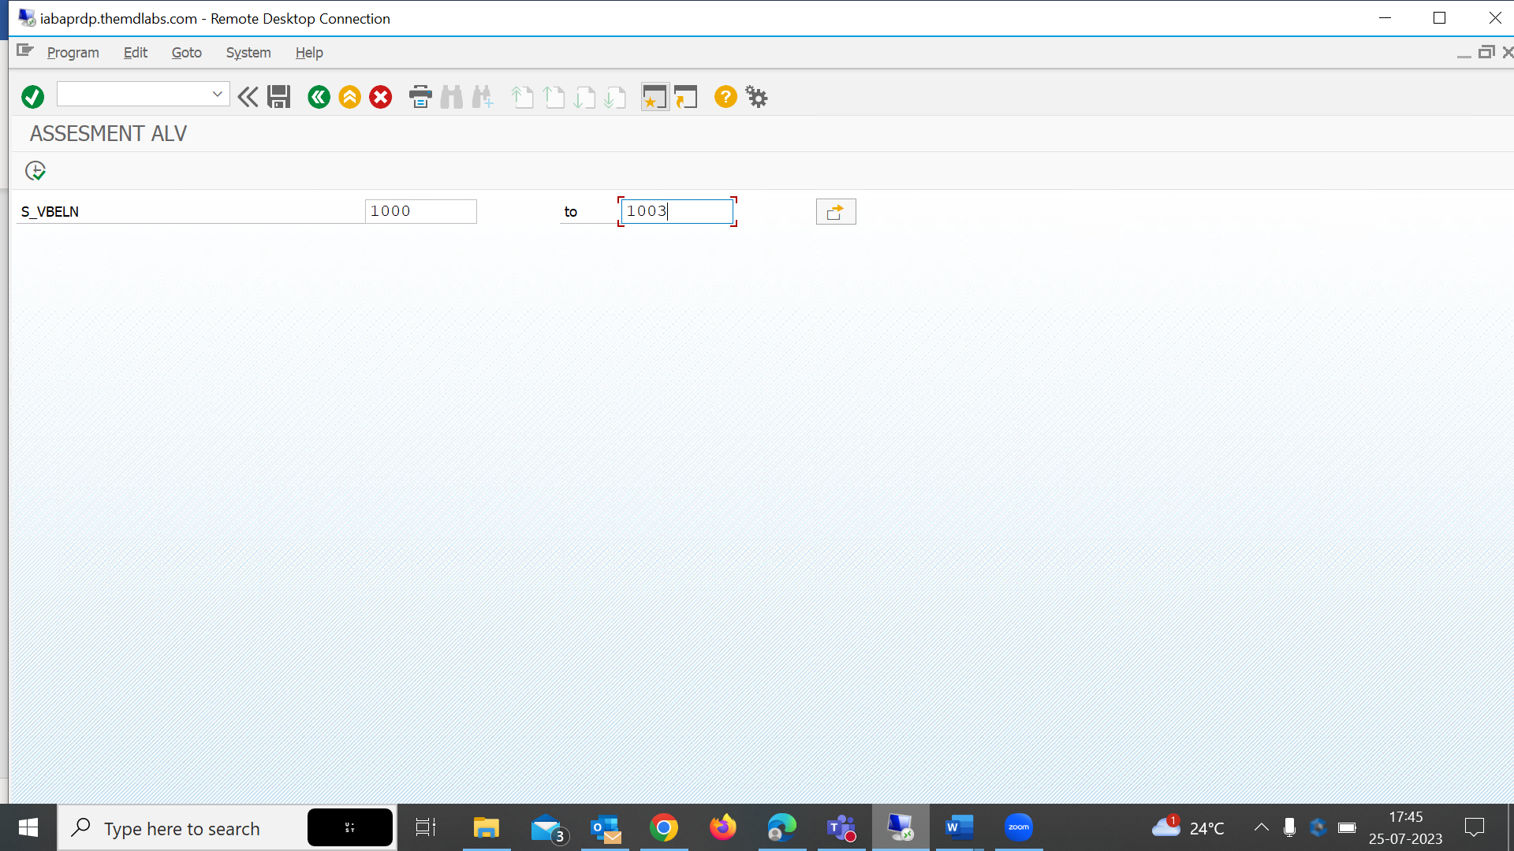

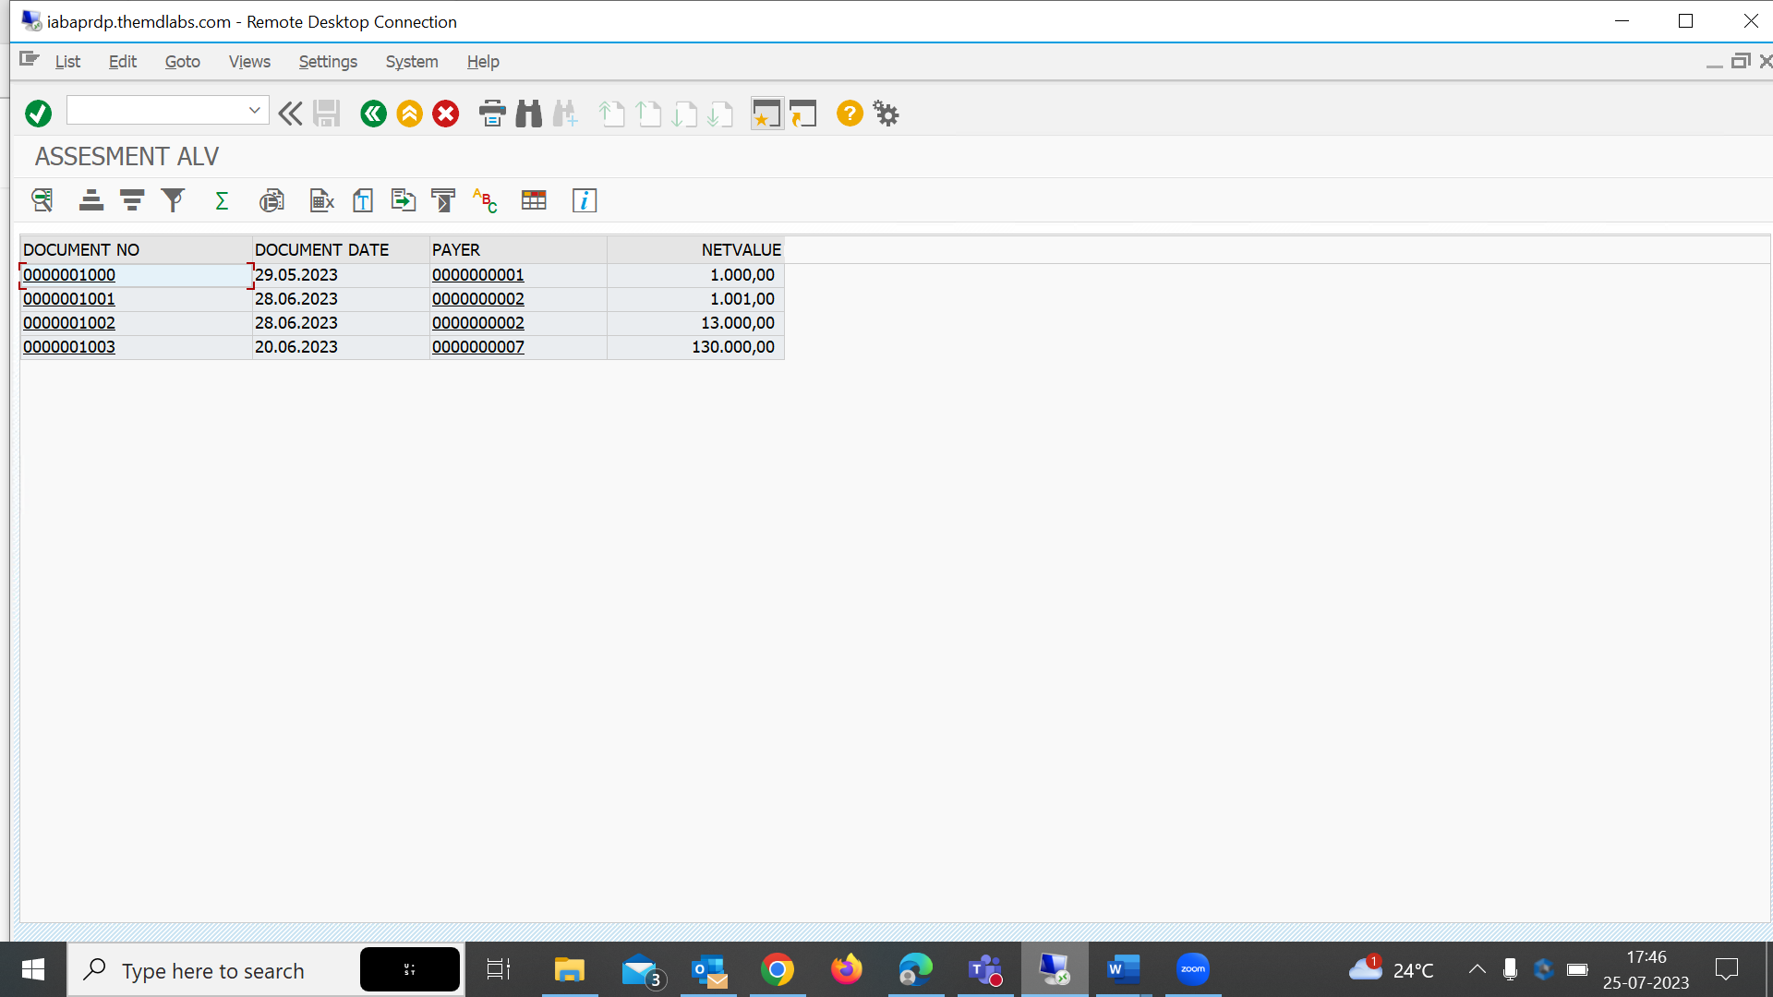

ITEM DATA

1000

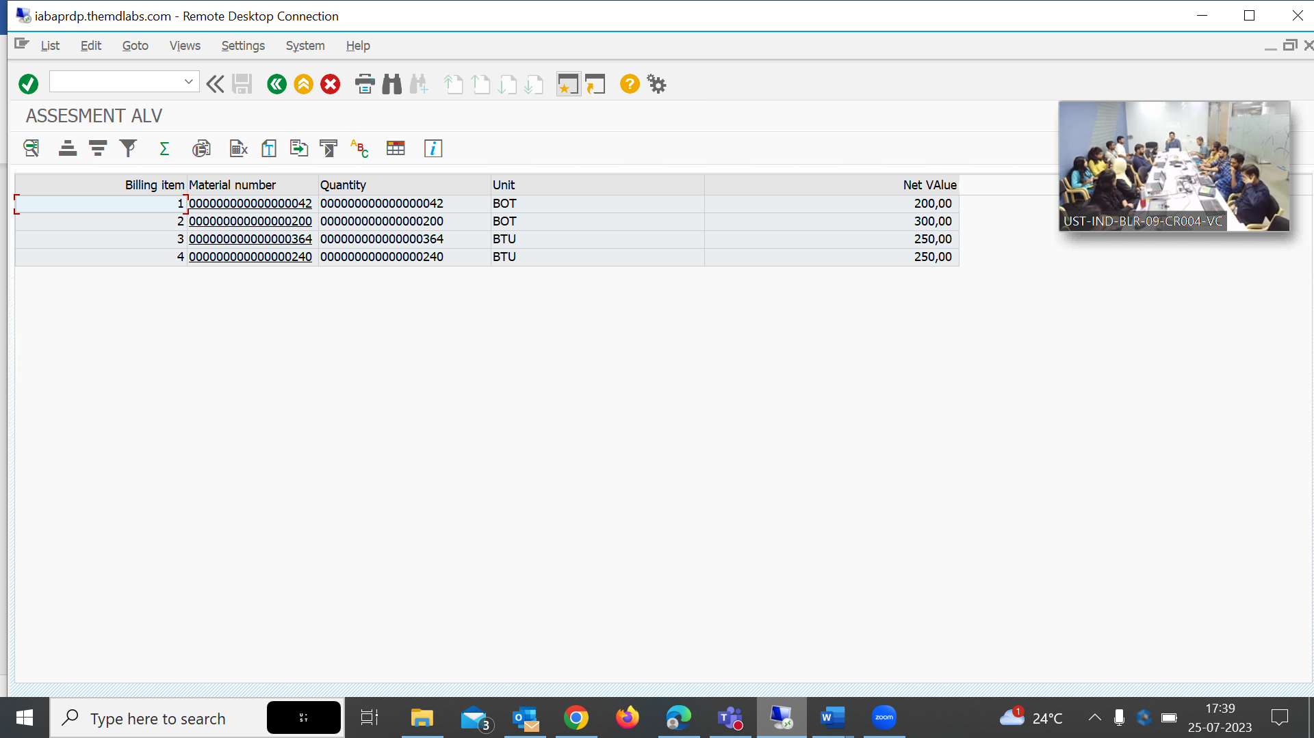

PAYER XD03

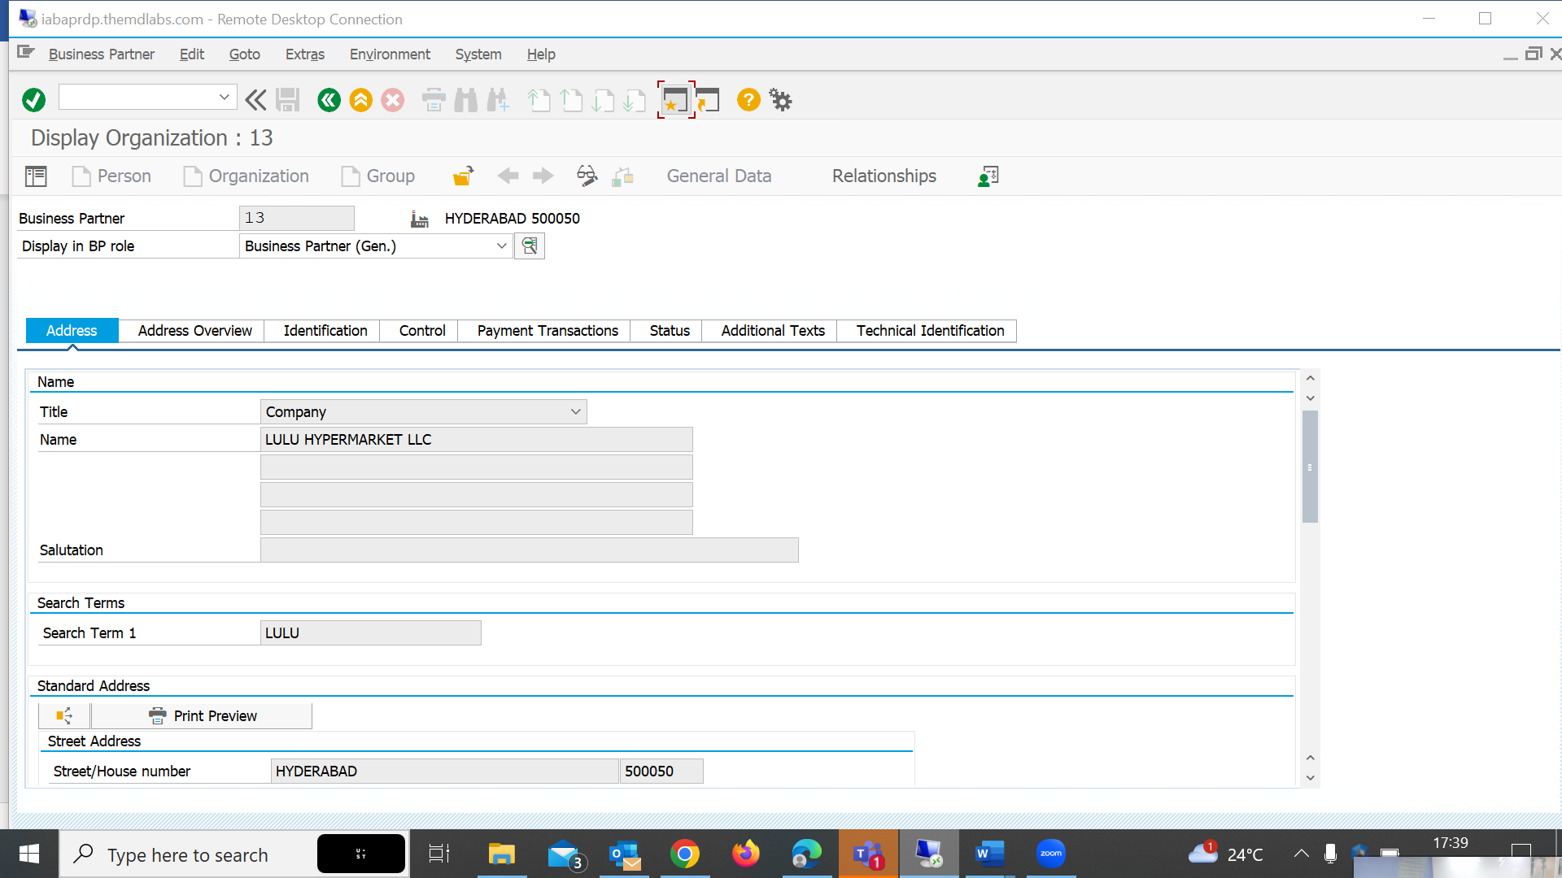

MATERIAL MM03

